Online Stock Market Simulation Project
Finance



Introduction
The financial markets are one of the most dynamic elements of the U.S. economy. The primary function of the financial markets is to channel funds from individuals, businesses and institutions that have funds to lend or invest to those individuals, businesses and institutions that need funds. For those that have funds to invest, the financial markets provide an opportunity to profit from their investments; for those that need funds, the financial market provides a source for those funds.
This project is designed to provide you with direct exposure to online investment in stocks and portfolio management using the tools available at http://www.howthemarketworks.com/. This site is quite similar to utilizing an online brokerage account. This project provides an opportunity for you to learn how the stock market works by creating a portfolio of U.S. stocks with the objective of maximizing investment returns over a specified period of time. Happy investing!!!!

Organization of these project instructions
These instructions are organized as follows.
- Pages 1 and 2 explain how to get started.
- Pages 3 and 4 deal with the form of your report and related matters.
- Pages 5, 6, set out the exact requirements that you need to fulfill – questions to be answered and screenshots from your “account”.
- Finally, beginning on page 8, I have provided examples of some of the screenshots you need to provide.

Creating an account

Try accessing this link for our contest:

https://www.howthemarketworks.com/register/139916

If you have trouble with the link, follow the direction below. You need to be in LIM’s contest for purposes of this project, so please be sure to follow these instructions precisely.
- Go to the website cited above. Either use ctrl + click the link above link or you can copy/paste the URL into your browser.
- When the window opens, click to register to the new site. Once there, register.
- If you need to log in once you register, please do that.
- Click on contests (middle top of site) then “find a contest”. When the next window opens, in the search bar next to “find contests” enter the name of the contest.
- In “find contests” enter LIM-Spring-online_2019-Sec.06 then click to join
- If you are asked for the contest password, it is limmoney06
- When you use the site, you will be primarily interested in “my portfolio” (and there are several things to look at here) and “make a trade”. Here is “my portfolio” (next page).
- You will also notice a link called “My Rankings”. If you click that, it will show exactly what it sounds like it will show: your standing in the contest. Some students enjoy that, enjoy the competitive aspect of it and find it motivating. Others “beat themselves up over it”. So you are welcome to check your ranking or not as you see fit.

I feel clueless!
As you begin, you may be at a loss as to how to choose your stocks. I would suggest the following approach to start. Choose companies with which you are familiar – as a customer, as an employee, from a research paper in another class (some feel guilty about using something from another class – there is no guilt here – that is called efficiency), etc. Research some/all of the following “short list” of criteria using a financial site (see the syllabus (“Optional Readings”) for list). You might consider the following in your preliminary research:
- Strong revenue growth*
- Strong earnings growth *
- Analyst ratings – what do the “experts” think? This is available in Yahoo finance.
- Is the price of the stock historically high or low? Create a graph in Yahoo finance.
- Diversification (buy stocks of different companies, perhaps in different industries)
- Try this link to see how much revenue or earnings growth companies have experienced in recent years. http://fortune.com/100-fastest-growing-companies/ . Remember, these are the top 100 companies – not every company will achieve these growth rates, but the data will help you gauge what constitutes strong revenue growth.
- This site may also be useful regarding revenue as well as profit growth. http://moneycentral.msn.com/investor. In the search bar, begin typing the name of the company and when its name appears in the drop down menu, click on it. Click on analysis and then click on growth and you will see the company’s recent growth in revenue and in net income, and a comparison of those growth rates to its industry. So you can see how the company has done as compared to its competitors.

Goal of the simulation
In the simulation, the companies and their stocks are real, and the prices are current – a true simulation of the market in “real time” – you are looking at the market here and now and the results you achieve represent what would have happened had you actually invested money in the stocks you chose. You will be given a hypothetical $100,000 at the outset of the simulation. Your goal is to invest that in stocks and produce as much wealth as possible by the end of the simulation. You can hold your stocks or sell them and buy others, as you see fit, subject to the requirements, below. Note that your grade is minimally impacted by your success in building your account wealth. I am more interested in your analysis of what you see during the simulation.

When can I buy or sell stock?
*******NOTE THAT YOU CAN ONLY BUY OR SELL STOCK WHEN THE STOCK MARKET IS OPEN IN NY. THAT IS FROM 9:30 AM TO 4 PM, MONDAY THROUGH FRIDAY. MADE SURE YOU ALLOW FOR THAT IN CREATING YOUR SCREENSHOTS THROUGHOUT THE SEMESTER.

Observing proper form in your final report:
The project is partly a writing project. So spelling, grammar, clarity of expression and observing APA style matter. I will post several resources to help guide you through the key points of APA. Be sure that your screenshots are legible. The project should look like a product you would be willing to place in front of your manager or in front of an important customer.

Deliverables:
- You cannot let this project slide until the final due date. In 4 of your assignments, including the first, I will ask you for screen shots related to your stock account. At the end of these instructions, I illustrate what needs to be visible in those 4 screenshots. These will be screenshots of your Open Positions, to include a) the “green banner at the top; b) a list of names and details of the stocks you own and c) the first Motley Fool Headline. The purpose of the Motley Fool Headline is to allow me to see the date of your screenshot. Again, see my sample screen shots at the end of this document. Along with the screenshot, write a sentence or two, saying something about what you see in your account – you have flexibility as to what you say, but make a short and meaningful observation. Any surprises? Did something work out as you expected? Etc. Just a sentence will do it…
- There is also a due date in the Course Calendar for the final Simulation Project report. On that date, need to upload to Blackboard a Word document that includes the following.
  - Your answers to the questions that appear later in these project instructions. Please do NOT try to create a continuous essay. Rather, your document should be in questions and answer format. Be sure the number of your answer corresponds to the number of the question.
  - A references page.
  - A fourth screen shot of your Open Positions, and the Motley Fool headline (see my description in #1, above).
  - A screenshot of “My Graph” that provides a comparison of your portfolio performance to “the market” - only one screenshot of this at the end of your simulation. This relates to question #8.
  - Your “Order History” – only one screenshot at the end of your simulation. This should cover all of your transactions for the entire simulation.
  - A screenshot of the window from moneysentral.com that contains the financial ratio you used to answer question #6.
  - Be sure all required screenshots are legible and are at the end of your Word document, after the references page. Absence of any of these screen shots will negatively impact your grade on the project. Please put them at the end of the project, as requested for full credit.

Submit your simulation project by uploading it to Blackboard by the due date. Name your file your last name_simulation.

Blackboard matters:

- Note that in the event of any Blackboard difficulties, you need to contact Blackboard Support. Guidelines for so doing are in the Blackboard shell for the course (see the Welcome Announcement and the link to Blackboard Support). Note that when you contact Blackboard, you need to ask them for a “trouble ticket” number. That will allow me to verify that you contacted them, and, if the problem cannot be resolved, will enable me to possibly give you permission to submit other than through Blackboard. Without the trouble ticket number, no submission outside of Blackboard will be permitted.
- Be sure that you upload only Word files. Word files will have a suffix .docx. Students sometimes upload other types of files that are not compatible with Blackboard. In such case, I will not be able to open your file and if I can’t open it, I can’t grade it.
- Note that PDF files are not acceptable.

Due Dates:
The due dates are set out in the course calendar. As indicated above, all deliverables should be submitted by uploading to Blackboard. Back up your work, as technological malfunctions will not be accepted as justification for a late submission. Late papers will be penalized 5 points for each calendar day they are late and, after a few days, may not be accepted at all, at my option, resulting in a zero grade for the project.

You need to submit 4 sets of Open Position screenshots during the semester (the screenshots will also be included in your Final Project), and then a 5th set as part of your final project. The dates of your screenshots are as follows:

- January 18
- February 15
- March 22
- April 12
Your Final Project is due on Sunday April 28th so the last screenshot should be the closest day to your submission.

Content of Report

The specific requirements for the project are set out below and are divided into 3 groups.

Requirements for the Project:

Group 1: Requirements that need ongoing attention

- You need to have a portfolio of at least 5 stocks for most of the simulation. You can start off with one or two companies, but you need to get up to 5 by the time you are required to upload your second set of screenshots (and thereafter) in order to earn full credit. Note that you are welcome to trade stocks (so you can sell some and buy others) or you can hold your initial stocks – that is up to you. But you must maintain at least 5 stocks for most of the simulation. (2 points)

- Invest as much of your cash as possible in stocks. You have $100,000 to invest, so invest it all! You can hold your stocks throughout the simulation or you can sell stocks, but if you sell, you need to reinvest the money so that your cash is no more than $5,000. Do not sell all your stocks at the end as that will cause your cash to be well over $5,000. You must have no more than $5,000 cash by the time you are required to upload your second set of screenshots (and thereafter) in order to earn full credit. (2 points)

- During the semester you will have uploaded 4 sets of screenshots along with a brief comment on each. You should include a 5th set of screenshots in your final report. Put the 5th set of screenshots at the end of your report. (15 points for the screenshots)

- The stock market is reactive to macroeconomic and geopolitical events or conditions– events/conditions that impact the national, or even the global economy (not events that impact only one or more of your companies such as the retirement of a key executive). To answer this one, you will need to develop a sense of macroeconomic events/conditions that impacted the market during the entire duration of the simulation. The purpose of this question is for you to keep abreast of national/world events, in particular as they will impact the stock market. Your goal in answering this question is to pick and explain the macroeconomic/geopolitical event that you believe most impacted the stock market during the entire simulations (not just for a few days) – on what were investors most focused during the simulation? Be sure to explain how this event impacted the stock market. I will make my own short list of such events/conditions and the more important the one that you pick, the more credit you will earn. This question requires you to keep current with happenings in the financial markets throughout the semester; reading a summary of market performance for a single day (or a few days) will not get the job done! (10 points)

Group 2: These requirements DO NOT necessarily require week to week attention BUT MUST BE INCLUDED IN YOUR FINAL REPORT

- Do not sell all of your stocks at the end. Part of the credit for the project depends upon how successful your investments were – nothing for you to do here – the value of your account will be based on your final account balance screen shot. Full credit for this question is 4 points and you will earn that amount of credit if your stock portfolio performed at least as well as the overall market. You can also earn some extra credit if your stocks outperformed the market, so you can earn a maximum of 6 out of 4. You will earn 6 points if your portfolio performed significantly better than the market during the simulation; 5 if better than the market; 4 if about the same as the market; 3 if worse than the market; and 2 if significantly worse than the market. Typically, no one earns less than 2 points, absent other issues, e.g. you did not provide the necessary screen shots in your final report.
- Choose one of your stocks. For that stock, choose any financial ratio that we discussed and which can be found on this site http://moneycentral.msn.com/investor. Press control and place your cursor over the link above and it will become “live” – click it to go to the site. Click “markets” and begin typing the name of the company in “quote search and when its name appears in the drop down menu, click on it. Under “Analysis”, the ratios we discussed will be listed in the categories of profitability, price ratios, financial health, and management effectiveness. Include a screenshot of the ratio you use from the moneycentral site when you submit your project. I have included some additional screen shots at the end of these instructions. These may be useful in answering this question. Place your screenshot beneath your answer to #6.
  - You will need the same ratio for the company and its industry (both are given in moneycentral). Name the ratio you chose. Be sure it is one of the ratios we covered. Be careful – the debt equity ratio is not the same as the debt ratio (which is debt to assets). What does the ratio tell you about the company compared to its industry? Be sure to convey the meaning of the ratio in your answer – don’t merely say “it’s good”. And be sure to compare to the industry in a way that tells me you understand the meaning of the ratio. (10 points)
  - Note that a single ratio comprises but a small piece of the financial research that can be done on a company, as we have discussed. Nonetheless answer this question based on the ratio you chose. Does the financial ratio information you reported above tend to support your purchase of this stock, or does this ratio raise some questions in your mind in retrospect? Don’t force the answer (it’s perfectly okay to say that the ratio is not favorable for your company – the key is to explain why). (4 points)
  - Again, be sure to include a screenshot of the MSN site, showing the ratio that you chose. You will lose credit without the screen shot. Place your screenshot beneath our answer to #6.
- Refer to our discussions of risk and return. Consider your portfolio fully diversified. So specific risk is about as low as it makes sense to take it and you are left with market risk. Which stock in your portfolio has exhibited the greatest market the risk over the past 60 months or so? How can you tell? In your answer, explain that risk measure briefly – how does it measure risk? You should be able to retrieve that measure from the msn site, link given above. (10 points) In answering this question, note the following.
  - This question is looking for reference to a particular risk measure and not conjecture on your part.
  - It is also looking for risk over a time frame longer than this simulation (60 months), to be exact).
  - The question refers to the stock’s market risk. So it is not looking for default risk or bankruptcy risk (which could be expressed by the debt or debt/equity ratios), so those ratios should not be used to answer this question.
  - If you are “stumped” by this question, re-review our discussion of risk and return and find a risk measure that will allow you to figure out an answer to this question. You can also consult the text’s discussion of market risk in Chapter 6.
- Go to Graph My Portfolio. Bring up a graph for 3 months. Be sure your graph covers 3 months, not 1 month. There are several measures of the performance of “the market”. Use the drop down menu to find the measure of the overall stock market that best represents the overall market, in your opinion. We have discussed at least 2 measures of the market – there are others and you can choose any of them, as long as they can be graphed in HYMW. Your goal is to use the drop down menu and create a graph with 2 curves on it: your portfolio and the measure of the market that you chose.
  - Include a screen shot of the above graph in your project. Put that screenshot beneath your answer to #8.
  - Briefly tell me what the measure you selected represents - Indicate how you know that this is a measure of “the market”. Why did you select this particular measure of the market (there are several)? Try to select the measure that you think makes the most sense. I do not feel there is a “right” answer as to the best measure, but a) it needs to be one that is in the HTMW graph AND b) I am most interested in your telling me why you picked the one you did.
  - Comment on how your stocks did relative to the market, based on what you printed. (8 points for #8)
- There is a document in Blackboard, called “Stocksquest strategies” (your professor will tell you precisely where the document is posted, e.g. Course Info or Coursework, etc.). The document describes several common investing strategies, taken from another web site. Which strategy (or strategies) best matches what you did in the simulation? Explain briefly. In order for me to grade your answer, I need to have a screenshot of your Order History. The screenshot should be beneath your answer to #9. (8 points)
- You began the simulation with $100,000, all in cash. We could say that your account was worth $100,000 at the outset of the simulation.
  - Based on the screenshot of your final Account Balances what is your account worth at the conclusion of the project? I should be able to verify your answer by looking at your final screenshot of your Account Balances so be sure you take the data you use to answer this question from that screenshot. (5 points)
  - In your Word document, how much total worth, in dollars, did you gain or lose during the simulation? I should be able to verify your answer by looking at your final screenshot of your Account Balances so be sure you take the data you use to answer this question from that screenshot. (5 points)
- Looking back on the simulation, identify one thing that, knowing what you know now, you would have done differently if you had the simulation to do over again. Your answer to this question needs to be different than your answer to #6. Explain briefly. Your answer needs to be specific. For example, an answer such as “I would do more research” will not earn much credit. If that is your feeling, provide specifics – what research would you do? (10 points)

Writing Requirements
- The project is not a formal research paper, with a theme and an introduction/body/conclusion format. Therefore the writing rubric attached to the course syllabus will NOT be used. Rather, for full credit, this project should be in question and answer format with answers numbered to correspond to the questions. Nonetheless, there is some writing, which accounts for 7 points of the credit for this project, and so you need to pay attention to
  - spelling
  - grammar
  - clarity of expression
  - legibility (e.g., if your printer is running out of ink, change the cartridge; be sure your screenshots are legible, etc.)
  - APA style, including documentation, etc. (7 points.)

Total credit for project: 100 points.

Navigating the http://moneycentral.msn.com/investor site. I need to see the particular ratio you are using in question #6. Here is how to get to that ratio:
Press CNTRL and click on the link above. You will see something like this. Enter the company in which you are interested in “quote search” and hit enter.

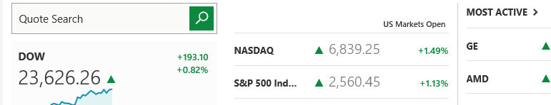
Decide which ratio you want to discuss. Then Click analysis and then one of the 4 categories indicated by my red arrows (profitability, price ratios, financial health, management effectiveness). We will have covered most or all of these - in parentheses, I indicate where to find the ratio in MSN – see my red arrows, below.
- Current ratio (Financial health)
- Quick ratio (Financial health)
- Inventory turnover (Management effectiveness)
- Operating profit margin (you can use Pre-tax profit margin as operating profit margin, under Profitability in MSN)
- Net Profit Margin (Profitability)
- Return on equity (Management effectiveness)
- Debt Ratio (unfortunately, this is not given in MSN)
- Price earnings (Price ratios)

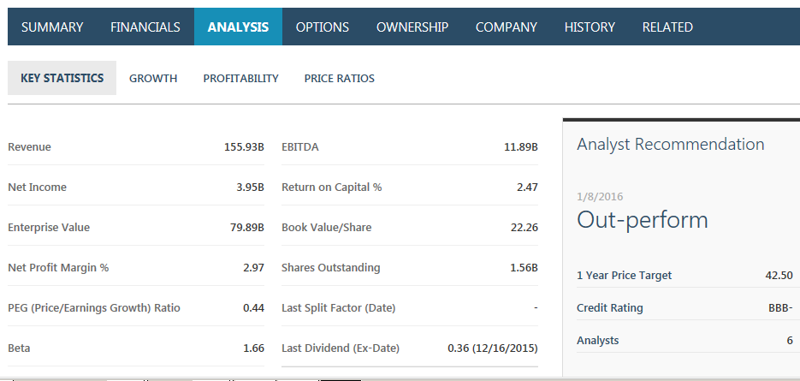

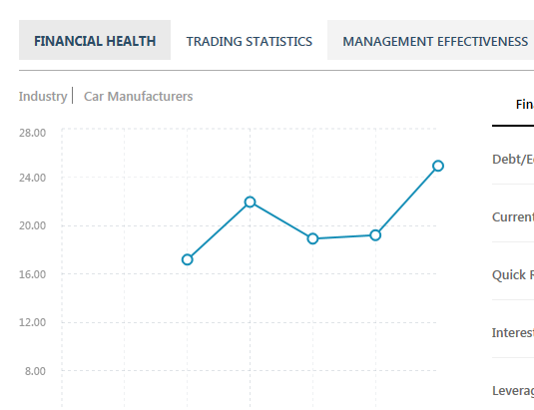

Note that I need a screen shot that shows the ratio you picked to be inserted into your report. So, if you picked the current ratio, you would click “financial health” and you would find the current ratio there. The screenshot below would need to be included in your report, under your answer to #6. You do not have to pick current ratio – pick any one that we covered – they are all easy to find in MSN if you follow these instructions.
